5/27/2021

**AMINA QADEER-359607**

**CE-42-A**

**CO-LAB -09**

**TO: Ma’am Rimsha Tariq**

CO-LAB -09

Final Report

**LAB TASKS:**

**Question #1:**

Write MIPS code to perform the following integer multiplications. What is the value of the LO and HI registers?

1. 98765 × 54321 using the multu instruction

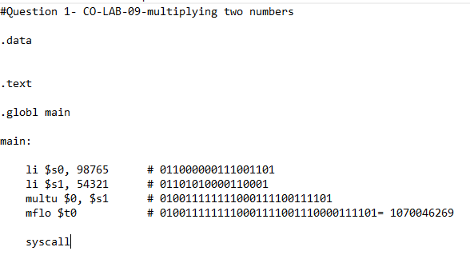

**Output:**

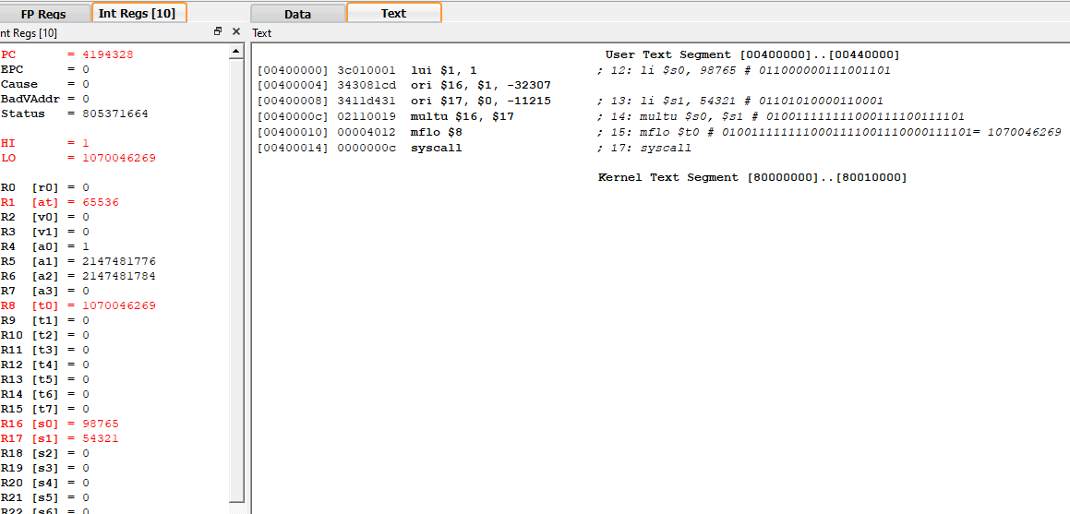

**In Binary:**

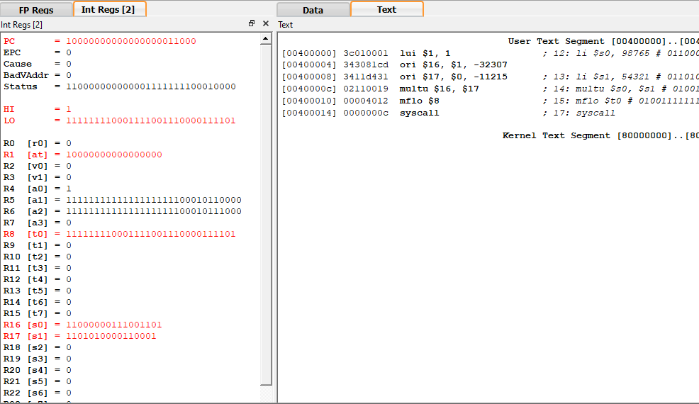

**Question 1(b):**

1. 98765 × 54321 using the mult instruction

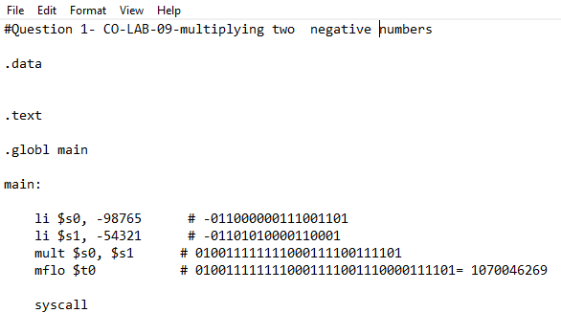

**Output:**

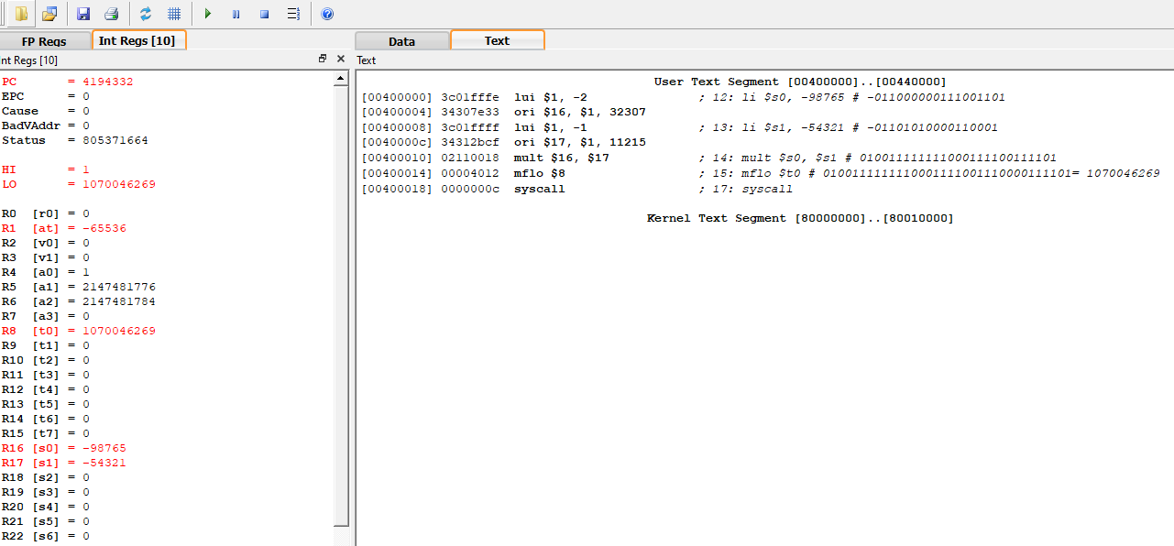

**In binary :**

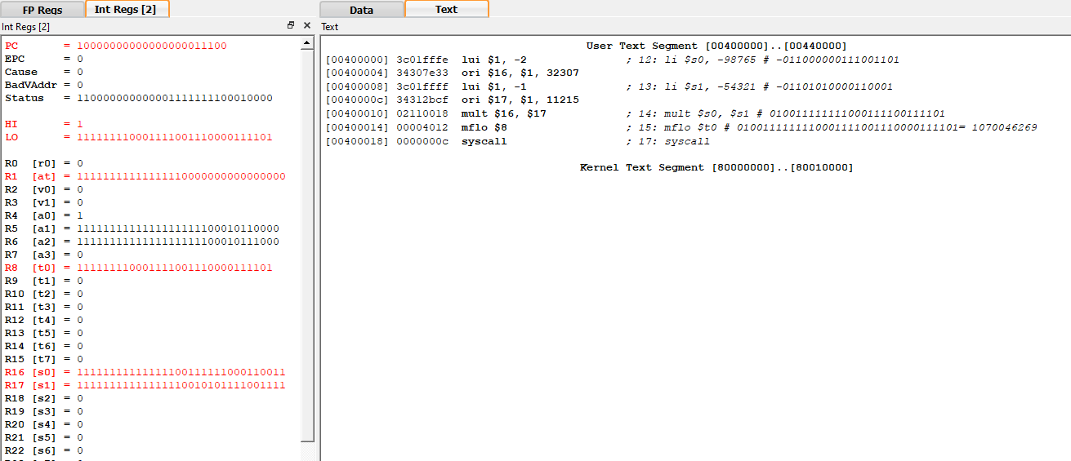

# Question no 02:

Write an assembly program

1. To multiply two decimal numbers 178 and 202 (if hi=0 then store lo in $s0)

**Code:**

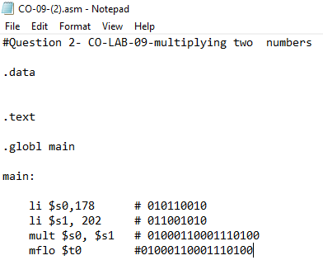

**OUTPUT:**

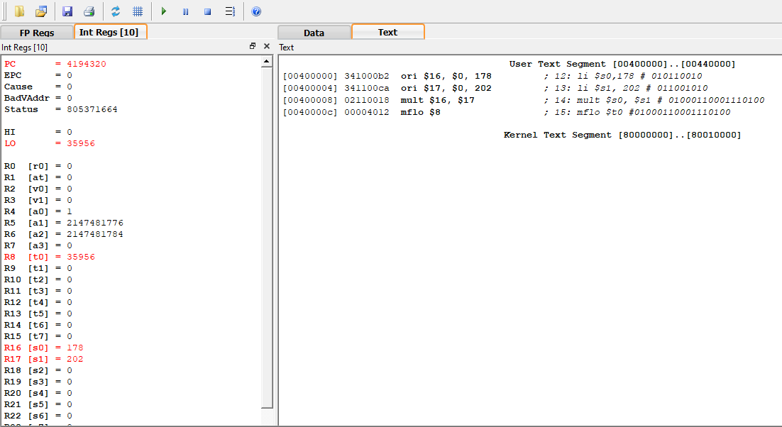

**In Binary:**

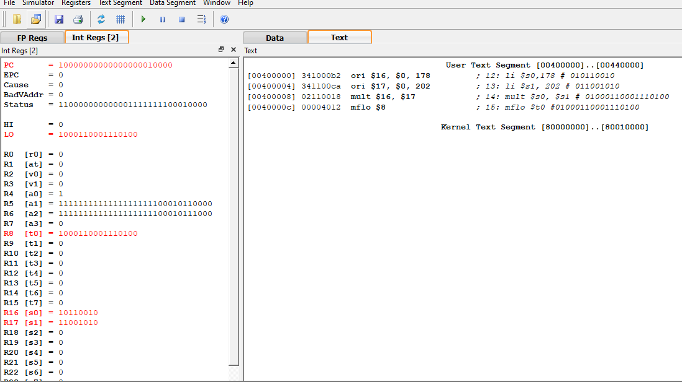

1. **To calculate the value of the expression 5x+74 (where x = 4)**

**Code:**

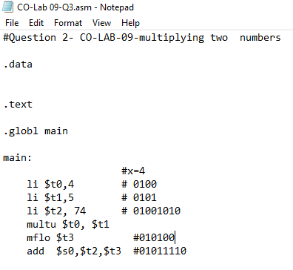

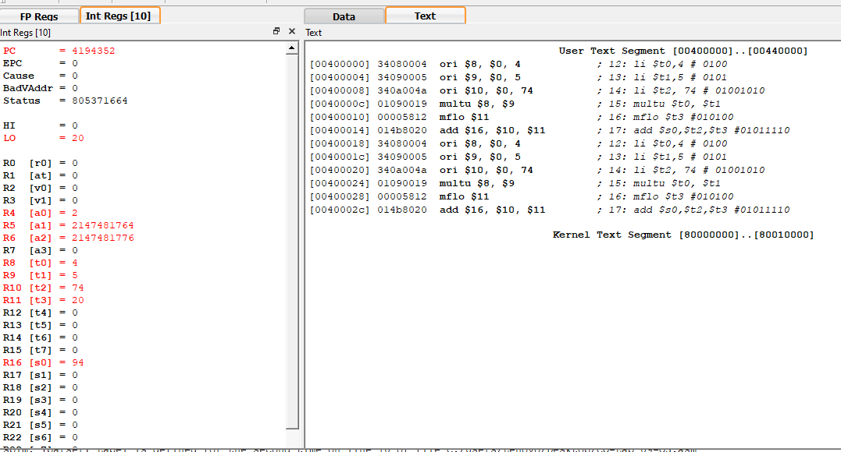

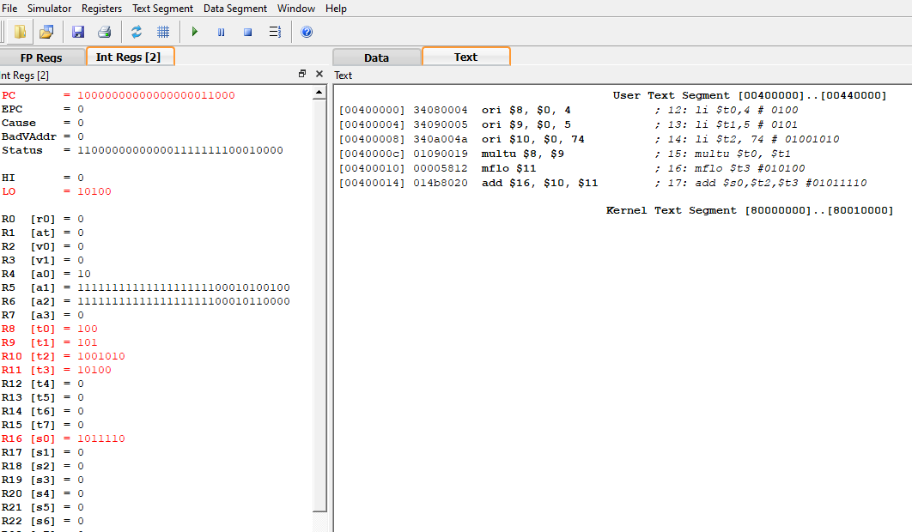

1. **To Calculate value 2y+3x+6 (where x=9 and y=7 ) Code:**

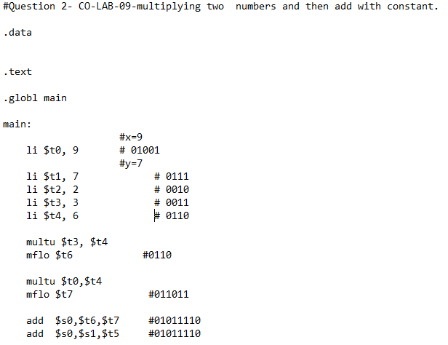

**In Binary:**

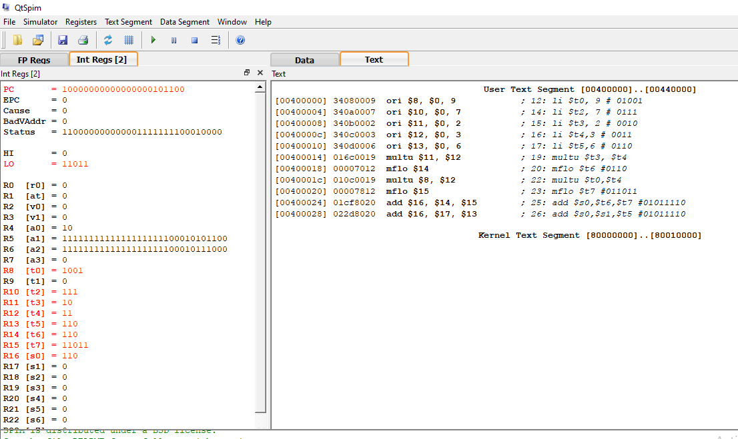

**In Decimal:**

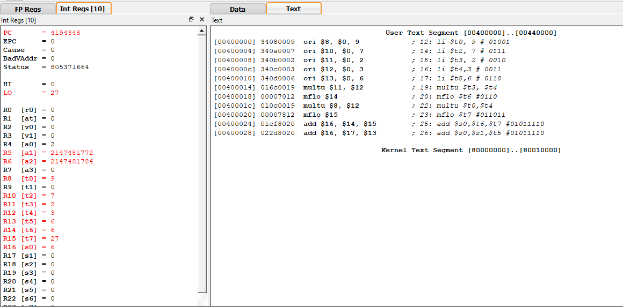

**Question no 03:**

**Write MIPS code to perform the following integer divisions. What is the value of the LO and HI registers?**

1. **98765 / 54321 using the divu instruction**

**Code:**

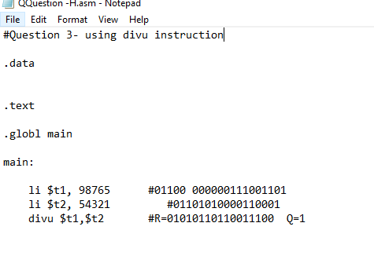

**OUTPUT:**

**In Binary:**

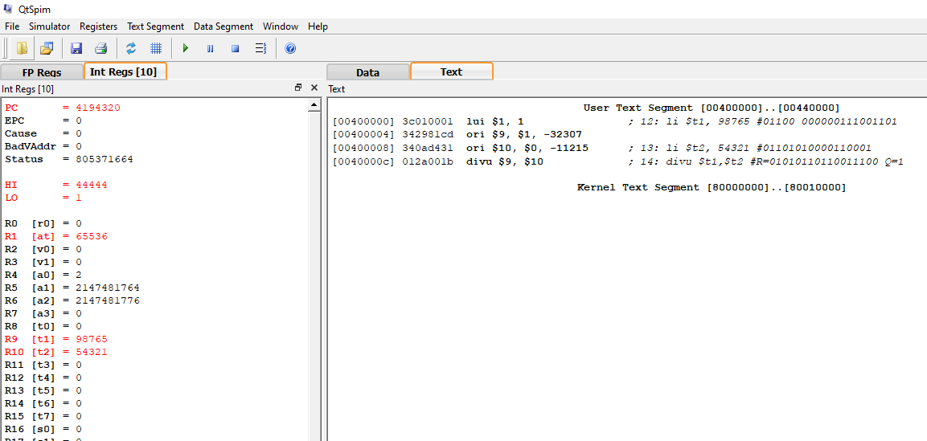

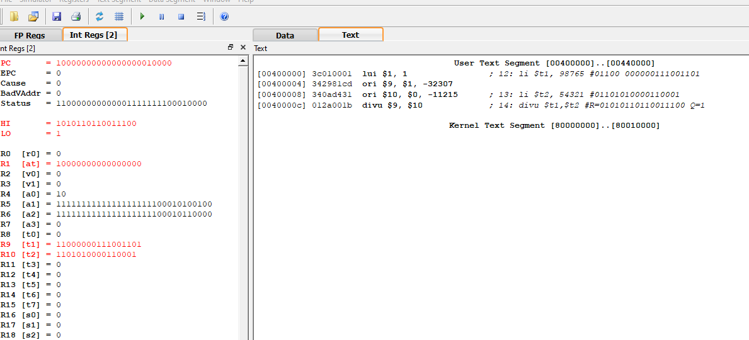

**b-98765 / -54321 using the div instruction**

**Code:**

**Output In Binary:**

;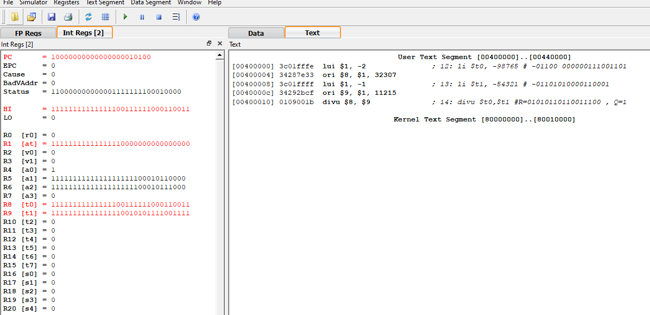

**In Decimal**

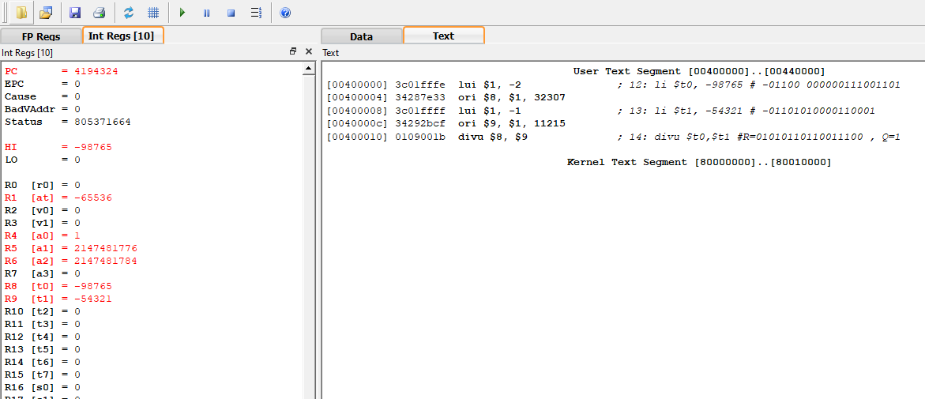

**THE END**